Exploring the Reef
Year 3
Learning area: Science
Science Understanding (sub-strand):
Biological sciences

© Commonwealth of Australia 2016
Published by the Great Barrier Reef Marine Park Authority
With the exception of the Commonwealth Coat of Arms, content supplied by third parties, logos and other material protected by a trademark, the content of this publication is licensed under the Creative Commons Attribution-Non Commercial-Share Alike 3.0 Licence.
A summary of license terms is available from
http://www.creativecommons.org/licenses/by-nc-sa/3.0/
The full license terms are available from
http://www.creativecommons.org/licenses/by-nc-sa/3.0/legalcode
This publication should be cited as:
Great Barrier Reef Marine Park Authority 2015, Exploring the Reef: Year 3 Australian science curriculum focus, GBRMPA, Townsville.
National Library of Australia Cataloguing-in-Publication entry
Exploring the Reef: year 3 Australian science curriculum focus / Great Barrier Reef Marine Park Authority.
ISBN 9781922126641
Coral reef ecology--Queensland--Great Barrier Reef--Study and teaching (Primary).
Coral reef animals--Queensland--Great Barrier Reef--Study and teaching (Primary).
Great Barrier Reef (Qld.)--Study and teaching (Primary).
Great Barrier Reef Marine Park Authority.
577.78909943

In this unit, the sections ‘Curriculum intent’, ‘Assessment – Assessing student learning’ and ‘Making judgements – achievement standard’ include content that is © Australian Curriculum, Assessment and Reporting Authority (ACARA) 2010 to present, unless otherwise indicated. This material was downloaded from the Australian Curriculum website (accessed March 2015) and was modified. The material is licensed under CC BY 4.0. Version updates are tracked on the Curriculum version history page of the Australian Curriculum website.
ACARA does not endorse any product that uses the Australian Curriculum or make any representations as to the quality of such products. Any product that uses material published on this website should not be taken to be affiliated with ACARA or have the sponsorship or approval of ACARA. It is up to each person to make their own assessment of the product, taking into account matters including, but not limited to, the version number and the degree to which the materials align with the content descriptions (where relevant). Where there is a claim of alignment, it is important to check that the materials align with the content descriptions (endorsed by all education Ministers), not the elaborations (examples provided by ACARA).
Comments and inquiries on this document should be addressed to:
Great Barrier Reef Marine Park Authority
2-68 Flinders Street
PO Box 1379
TOWNSVILLE QLD 4810
Australia
Phone: (07) 4750 0700
Fax: (07) 4772 6093
info@gbrmpa.gov.au
http://www.gbrmpa.gov.au
Exploring the Reef — Year 3
Contents
Unit overview 5
Teacher information 6
Curriculum intent 12
Feedback 17
Assessment 18
Sequencing teaching and learning 19
Making judgements 20
Teaching sequence 21
Resources 43
Resource 1 – TWLH chart 44
Resource 2 – Word bank 45
Resource 3 – Student reflections 46
Resource 4 – Classifying things 47
Resource 5 – Coral fact sheet 48
Resource 6 – Fish fact sheet 50
Resource 7 – Special symbiotic relationships fact sheet 52
Resource 8 – Procedural text – pollution experiment 54
Resource 9 – Great Barrier Reef games 56
Resource 10 – Cause-and-effect chart 1 59
Resource 10 – Cause-and-effect chart 2 60
Resource 11 – Student task sheet and Guide for making judgements 61

Unit overview
Unit title | Exploring the Reef
Learning Area | Science
Science Understanding  (sub-strand) | Biological sciences
Year level | 3
Duration | Approximately seven weeks (13 lessons)*  *based on 2 lessons of science per week for Year 3 (50 minutes per lesson)
Unit description | In this unit, students will investigate living and non-living things (including things on the Great Barrier Reef). They will observe and group things as living or non-living based on observable features. They will explore the characteristics of living things. Students will identify natural and human threats to living things on the Reef and recognise how science can help people understand threats to the Reef such as oil spills and the effect of human actions.

Teacher information

Safety and risk management
You will need to identify safety issues and conduct your own curriculum activity risk assessments for all activities and excursions in this unit.
For advice and documents refer to the Department of Education and Training Curriculum Activity Risk Assessment Guidelines: http://education.qld.gov.au/health/safety/hazards/curriculum-activities.html
The actual risk level for activities in this unit will vary according to the specific circumstances of the activity and your school and classroom context. You must consider all specific circumstances when you complete a risk assessment. Examples of considerations include, but are not limited to:
- Is the activity occurring within, or outside of school grounds e.g. an excursion?
- How will students be supervised during the activity?
- What will students do during the activity?
- Are there any special student considerations e.g. medical, behavioural or special needs?
- What hazards do you need to take into account e.g. hazardous substances, tools or equipment?

Unit details
The Great Barrier Reef Marine Park Authority (GBRMPA) Exploring the Reef unit is a Year 3 Science unit of work. The content descriptions for this unit are from the Australian Curriculum: Science (Version 7.4 dated 30th March 2015 http://www.australiancurriculum.edu.au).
The unit follows the inquiry-based 5Es approach to teaching science. The inquiry questions that underpin the unit are:
- What is the Great Barrier Reef?
- What are living and non-living things?
- What are the survival needs and features of marine life on the Great Barrier Reef?
- What are some of the relationships between animals, plants and living and non-living things on the Great Barrier Reef?
- What are the current threats to the Great Barrier Reef?
- Are there ways the Great Barrier Reef can be protected?

Time allocation
The unit is based on two lessons of science per week for Year 3 students. Each lesson is approximately 50 minutes long.
The overall unit, or the individual lessons, can be extended or shortened to cater for individual classes as deemed necessary by the class teacher.

Unit aims
The lessons in this unit are structured to build students’ knowledge of the Great Barrier Reef and to make links between different features of the Reef and the specific needs of living things.
Students will be able to identify a range of features of living and non-living things found on the Reef and explain the relationships between those things. Students will also research threats to the Reef and identify ways to care for the Reef.
The health of individual marine life on the Great Barrier Reef is vital to the health of the Reef overall. For more information on the Great Barrier Reef see the section ‘Background information – the Great Barrier Reef’ and also http://www.gbrmpa.gov.au. Teaching students about living and non-living things on the Reef will build their environmental knowledge and encourage their understanding of sustainability and stewardship.

Key threats to the Reef
GBRMPA encourages teachers, students and communities to follow the main aim of Reef Guardians – to be custodians of their local ecosystems and stewards of the Reef. In the Great Barrier Reef Outlook Report 2014, the key threats to the reef are climate change, land-based run-off, coastal development and other direct impacts such as unsustainable fishing activities and marine debris. (See http://www.gbrmpa.gov.au for more information on the Outlook Report 2014).
In this unit, students explore threats to marine habitats and the Great Barrier Reef such as the impact of oil pollution or marine debris. Student could also consider human impacts to local habitats, such as littering and be guided to see the connection between this and debris on the reef.

Stewardship
The Reef Guardian Schools Program encourages responsible use and protection of the Great Barrier Reef ecosystems. Schools are encouraged to take ownership of conservation activities and on-ground projects that involve students, teachers and their local communities. These environmental actions foster a greater appreciation and understanding of the Great Barrier Reef and empower students to become lifelong stewards.
The following are examples of stewardship activities that relate to the learning experiences of this unit:
- Write to parents via the school newsletter to suggest actions that foster household sustainability and reduce negative effects on the Reef e.g. fishing practices, recycling, not releasing helium balloons, etc.
- Find ways to minimise classroom electricity to build awareness of climate change and action.

Citizen science participation
Citizen science is scientific research conducted by non-professionals – in this case by students, teachers and communities. Schools can participate in the collection and submission of scientific data to local management authorities including GBRMPA, local councils and local Natural Resource Management agencies where the data can be used to inform sustainable ecosystem management decisions.

Building partnerships
Delivery of this unit can be enhanced by building partnerships within the school and wider community.
Partner organisations could include the following:
- local council
- Local Marine Advisory Committee (LMAC)
- your nearest Natural Resource Management Agency (NRM) and conservation groups
- other schools
- parents or local aquarium shop owners, local zoo experts that can visit and discuss looking after aquaria
- traditional owners to discuss their relationship with land and sea and the Reef
- local aquariums e.g. Reef HQ or Underwater World.

Background information – The Great Barrier Reef

The Great Barrier Reef Marine Park:
- is the largest coral reef system in the world
- has 2900 reefs
- has 600 continental islands
- has 300 coral cays
- covers 344 000 km2
- is approximately 2300 km in length
- extends from the northern tip of Queensland south to just north of Bundaberg
- is between 60 km and 250 km in width
- has an average depth of water of 35 m in the Great Barrier Reef Lagoon
- is one of the largest marine protected areas in the world (about 344 000 km2)
- includes the air above and the earth beneath the sea
- was created in 1975 under legislation called the Great Barrier Reef Marine Park Act 1975.

Types of habitats in the Great Barrier Reef Marine Park
Only six percent of the Great Barrier Reef Marine Park consists of coral reefs. The rest is made up of seagrass, mangroves, sand, algal and sponge gardens, inter-reef communities and other habitats. It is home to:
- 1500 species of fish
- 360 species of hard coral
- one third of the world’s soft corals
- 5000-8000 species of molluscs (e.g. shells)
- 400-500 species of marine algae
- 600 species of echinoderms (e.g. starfish, sea urchins)
- 17 species of sea snakes
- 22 species of seabirds and 32 species of shorebirds that live and breed on the islands
- 13 000 dugongs (Australia’s entire dugong population is about 90 000)
- six species of marine turtles, all listed as threatened (including the endemic flatback marine turtle)
- 30 species of cetaceans (whales and dolphins).

Importance of a healthy Great Barrier Reef Marine Park
(Great Barrier Reef Outlook Report 2009, http://www.gbrmpa.gov.au)
The Great Barrier Reef is a national and international icon, famous for its beauty and vast scale. It is the largest and best known coral reef ecosystem in the world. The reefs of the Great Barrier Reef (almost 3000 in total) represent about 10 percent of all the coral reef areas in the world. Virtually all groups of marine plants and animals are abundantly represented in the Great Barrier Reef, with thousands of different species living there.
The Great Barrier Reef Marine Park supports a wide range of uses including commercial tourism, defence activities, fishing, ports and shipping, recreation, scientific research and Indigenous traditional use. It brings billions of dollars into Australia’s economy each year and supports more than 50 000 jobs.
A number of activities such as mining and oil drilling are strictly prohibited within the Great Barrier Reef Marine Park. There is careful management of all other activities such as fishing, commercial marine tourism and shipping operations. A range of measures are employed to manage the various uses of the Marine Park and to protect its values. For example, a Zoning Plan defines what activities can occur in each location, both to protect the marine environment and to separate potentially conflicting activities.
About 70 Great Barrier Reef Aboriginal and Torres Strait Islander Traditional Owner clan groups hold a range of past and present heritage values for their land and sea country and for surrounding sea countries. These values may be cultural, spiritual, economic, social or physical, and demonstrate continuing connections with the Great Barrier Reef region and its natural resources.
The Great Barrier Reef was inscribed on the World Heritage List in 1981, the first coral reef ecosystem in the world to have this distinction and the only coral reef region that has ever qualified on all four natural criteria. This recognition continues to highlight the international significance of the Great Barrier Reef. It also carries an obligation and responsibility to protect and conserve its values for all future generations and to present its values to the world.

Useful websites
- Reef vid – a resource of free coral reef video clips -
http://www.reefvid.org/
- The Great Barrier Reef Marine Park Authority -
http://www.gbrmpa.gov.au
- Canisius College Ambassadors for Conservation – information about animal and plant relationships on the Great Barrier Reef (select ‘Great Barrier Reef’ under the ‘Learn about Wildlife’ tab):
http://www.conservenature.org
- National Geographic – Ocean Photo Galleries - quality images of marine life in the oceans:
http://ocean.nationalgeographic.com/ocean/photos/oceans-galleries-main/
- National Geographic – Great Barrier Reef - this article on the Great Barrier Reef includes several photo galleries and an interactive map of the Reef:
http://ngm.nationalgeographic.com/2011/05/great-barrier-reef/holland-text
- PBS – Evolution – Survival - a good interactive activity to show symbiotic relationships:
http://www.pbs.org/wgbh/evolution/survival/coral/
- YouTube link – Coral spawning on the Great Barrier Reef 2009 with TUSA dive - filmed on the Great Barrier Reef. Good images of coral spawning:
http://www.youtube.com/watch?v=eRZczb96uDo&feature=related
- YouTube link – Coral Spawning, Ningaloo Marine Park, Western Australia - filmed on Ningaloo Reef:
http://www.youtube.com/watch?v=JYm_WV8-CbU&feature=related
- YouTube link – Exploring Oceans: Great Barrier Reef - good National Geographic clip showing many aspects of the reef:
https://www.youtube.com/watch?v=wbNeIn3vVKM
- Queensland Wetlands Program: WetlandInfo
http://www.wetlandinfo.derm.qld.gov.au

Useful books
- I’m the biggest thing in the Ocean, Kevin Sherry (also see YouTube clip)
- One Less Fish, Kim Michelle Toft and Allan Sheather
- The Great Barrier Reef Book Solar Powered, Mark Norman
- The World That we Want, Kim Michelle Toft
- Big Picture Book of the Great Barrier Reef, Steve Parish
- Dhyum the Dugong, Mariana Fuentes (You can select and download the book as a PDF at the base of this website: http://www.coralcoe.org.au/education-outreach/booklets-and-stories).

Curriculum intent

Australian Curriculum: Science

Year 3 Level Description
The Science Inquiry Skills and Science as a Human Endeavour strands are described across a two-year band. In their planning, schools and teachers refer to the expectations outlined in the achievement standard and also to the content of the Science Understanding strand for the relevant year level to ensure that these two strands are addressed over the two-year period. The three strands of the curriculum are interrelated and their content is taught in an integrated way. The order and detail in which the content descriptions are organised into teaching/learning programs are decisions to be made by the teacher.
Over Years 3 to 6, students develop their understanding of a range of systems operating at different time and geographic scales. In Year 3, students observe heat and its effects on solids and liquids and begin to develop an understanding of energy flows through simple systems. In observing day and night, they develop an appreciation of regular and predictable cycles. Students order their observations by grouping and classifying; in classifying things as living or non-living they begin to recognise that classifications are not always easy to define or apply. They begin to quantify their observations to enable comparison, and learn more sophisticated ways of identifying and representing relationships, including the use of tables and graphs to identify trends. They use their understanding of relationships between components of simple systems to make predictions.

Content descriptions
This unit provides opportunities for students to engage in the following Australian Curriculum Content descriptions:
Science Understanding (SU) | Science as a Human Endeavour (SHE) | Science Inquiry Skills (SIS)
Biological sciences  - Living things can be grouped on the basis of observable features and can be distinguished from non-living things (ACSSU044) | Use and influence of science  - Science knowledge helps people to understand the effect of their actions (ACSHE051) | Planning and conducting  - Safely use appropriate materials, tools or equipment to make and record observations, using formal measurements and digital technologies as appropriate (ACSIS055)  Communicating  - Represent and communicate ideas and findings in a variety of ways such as diagrams, physical representations and simple reports (ACSIS060)

Year 3 achievement standard
By the end of Year 3, students use their understanding of the movement of the Earth, materials and the behaviour of heat to suggest explanations for everyday observations. They describe features common to living things. They describe how they can use science investigations to respond to questions and identify where people use science knowledge in their lives.
Students use their experiences to pose questions and predict the outcomes of investigations. They make formal measurements and follow procedures to collect and present observations in a way that helps to answer the investigation questions. Students suggest possible reasons for their findings. They describe how safety and fairness were considered in their investigations. They use diagrams and other representations to communicate their ideas.

General capabilities
This unit provides opportunities to address the following organising elements of the general capabilities:
Literacy  - Comprehending texts through listening, reading and viewing  - Composing texts through speaking, writing and creating  - Text knowledge  - Grammar knowledge  - Word knowledge  - Visual knowledge | ICT capability  - Investigating with ICT  - Managing and operating ICT
Numeracy  - Use special reasoning | Critical and creative thinking  - Inquiring – identifying, exploring and organising information and ideas  - Generating ideas, possibilities and actions  - Reflecting on thinking and processes
Personal and social competence  - Self-awareness  - Self-management  - Social awareness  - Social management | Ethical understanding  - Understanding ethical concepts and issues  - Reasoning in decision-making and actions
Intercultural understanding
- Recognising culture and developing respect
- Interacting and empathising with others

Cross-curriculum priorities
This unit provides opportunities for students to address aspects of the following cross-curriculum priorities:
Sustainability
Students will:
- recognise cause and effect relationships
- identify how scientific knowledge provides the basis of decision-making and helps people understand the effect of their actions
- understand the importance of caring for the environment.

Relevant prior curriculum
Students require prior experience from Year 2 with:

Science Understanding

Biological Sciences
- Living things grow, change and have offspring similar to themselves (ACSSU030)

Science as a Human Endeavour

Use and influence of science
- People use science in their daily lives, including when caring for their environment and living things (ACSHE035)

Curriculum working towards
The teaching and learning in this unit works towards the following in Year 4:

Science Understanding

Biological Sciences
- Living things have life cycles (ACSSU072)

Science as a Human Endeavour

Use and influence of science
- Science knowledge helps people to understand the effect of their actions (ACSHE062)

Feedback

Supportive learning environment
Differentiation  Consider the individual needs of your students – including gifted and talented, ESL and students requiring additional support.  For information refer to the Australian Curriculum, Assessment and Reporting Authority (ACARA) web pages on student diversity:  http://www.australiancurriculum.edu.au/studentdiversity/student-diversity-advice  Further information for Queensland state schools can be found as part of the P-12 curriculum, assessment and reporting framework and associated resources:  http://education.qld.gov.au/curriculum/framework/p-12/ | Feedback to students  Teachers:  - plan opportunities for conversations to provide ongoing feedback (spoken and written) and encouragement to students on their strengths and areas for improvement  - reflect on and review learning opportunities to individualise learning experiences required  - provide multiple opportunities for students to experience, practise and improve knowledge, processes and skills.  Students:  - identify what they can do well and what they need to improve  - provide feedback to a peer on interaction skills and suggest some strategies for improvement (written and spoken feedback).
Reflection on the unit plan
At the conclusion of the unit, teachers can reflect on it for future planning by answering the following questions:
- What worked well in this unit?
- What was a stumbling block?
- How would you refine it?
- What trends and gaps in learning have you identified?
- How will you build on these learning experiences next term and beyond?

Assessment
Assessment is the purposeful, systematic and ongoing collection of information as evidence for use in making judgements about student learning and to support improving student learning.

Monitoring student learning
Student learning should be monitored throughout the unit. Each lesson in this unit provides opportunities for monitoring learning and for gathering evidence of student progress. For examples of ways to monitor learning, refer to each of the lesson plans under the section ‘Teaching sequence’.

Assessing student learning
Summative assessment task: | Great Barrier Reef – poster and report (Lesson 11-13)
Description: | Students will create a poster of a Great Barrier Reef habitat. Students will identify and describe the observable features of living and non-living things in the Great Barrier Reef habitat. Students will explain why things they have identified are living. Students will write a simple report on a threat to living things on the Great Barrier Reef and ways to address the threat.
This assessment task provides opportunities to gather evidence of student learning in: | Science Understanding  Biological sciences  - Living things can be grouped on the basis of observable features and can be distinguished from non-living things (ACSSU044)  Science as a Human Endeavour  Use and influence of science  - Science knowledge helps people to understand the effect of their actions (ACSHE051)  Science Inquiry Skills  Communicating  - Represent and communicate ideas and findings in a variety of ways such as diagrams, physical representations and simple reports (ACSIS060)
See Resource section: Resource 11 for the Student task sheet and the Guide for making judgements for the assessment task: Great Barrier Reef – poster and simple report

Sequencing teaching and learning
A suggested learning sequence for this unit is summarised below. For detailed information for each lesson in this sequence go to the section ‘Teaching Sequence’.
Inquiry phase | Lesson | Purpose
Engage | Lesson 1: The Great Barrier Reef | To capture interest and discover what students think they know about the Great Barrier Reef.
Explore | Lesson 2: What do we know about the Great Barrier Reef? | To explore in detail what students know about the Great Barrier Reef.
 | OPTIONAL Lesson: Can we set up our own aquarium? | To observe and learn how to care for fish and other living things by setting up or exploring an aquarium.
Explain | Lesson 3: What is living and non-living? | To identify what makes something living or non-living and group things based on characteristics.
 | Lesson 4: Can you classify things on the Great Barrier Reef? | To classify things on the Great Barrier Reef into groups based on observable features.
 | Lesson 5 - 7: What living things live on the Great Barrier Reef? | To research different marine animals from the Great Barrier Reef.
 | Lesson 8: How can pollution affect the Great Barrier Reef? | To investigate the effect of oil pollution in an experiment.
Elaborate | Lesson 9 - 10: What threatens the survival of living things on the Great Barrier Reef? | To use Cause-and-effect charts to identify threats to living things on the Great Barrier Reef.
Evaluate | Lesson 11-13: Reflections and assessment task | To review and reflect on learning and introduce and complete the assessment task.
TOTAL: 13 Lessons (50 minutes per lesson)

Making judgements

Achievement standard
In this unit, assessment of student learning aligns to the following components of the Year 3 achievement standard.
By the end of Year 3, students use their understanding of the movement of the Earth, materials and the behaviour of heat to suggest explanations for everyday observations. They describe features common to living things. They describe how they can use science investigations to respond to questions and identify where people use science knowledge in their lives.
Students use their experiences to pose questions and predict the outcomes of investigations. They make formal measurements and follow procedures to collect and present observations in a way that helps to answer the investigation questions. Students suggest possible reasons for their findings. They describe how safety and fairness were considered in their investigations. They use diagrams and other representations to communicate their ideas.

Guide for making judgements
See Resource section: Resource 11 for the Student task sheet and the Guide for making judgements for the assessment task: Great Barrier Reef – poster and simple report.

Teaching sequence
Engage
Explore
Explain
Elaborate
Evaluate

Lesson 1: The Great Barrier Reef
Duration: 50 minutes

Lesson objectives
Students will:
identify and communicate what they already know about the Great Barrier Reef.

Suggested learning sequence

Introduction - Book reading
- Read a book to the students about the Great Barrier Reef such as the Big Picture Book of the Great Barrier Reef by Steve Parish.
- Ask students to share what they know of the Great Barrier Reef, record student comments on the T of a class or individual TWHL chart. (See Resource 1 – TWLH chart for individual charts). Add to the TWHL chart throughout the unit and use it as a reflection tool during the Evaluate phase of the unit.
T  What we think we know about the Great Barrier Reef | W  What we want to learn about the Great Barrier Reef | L  What we learned about the Great Barrier Reef | H  How we know (scientific understanding)
Activity – Reef display
- Ask students to draw or write (or both) a picture about what they know about the Great Barrier Reef. This may simply be about an animal they know that lives on the Great Barrier Reef or an experience they have had visiting the Great Barrier Reef.
- Students should label their pictures to show their knowledge of language associated with the Great Barrier Reef.
- Use these drawings/writings to start a class Reef display. Encourage students to add to this display throughout the unit and ensure students understand the Great Barrier Reef is a multiple use area and rules apply to what you can take from it.
- The display might include photos, pictures, books, GBRMPA images, drawn images of animals and plants, or items students may have found washed up on the beach e.g. shells, fish bones, crab cases.
- As a part of the display, also start a word wall to continuously add to throughout the unit. (See Resource 2 – Word bank for examples of vocabulary). This should be displayed in a place where students can add to it each lesson. It may be done in alphabetical order or on moveable cards so that students can interact with the words and sort them into categories as they progress throughout the unit.
- Start a science journal with the students to record their learning and reflections after each science lesson. (See Resource 3 – Student reflections for examples of sentence starters you can use to guide student reflections). The science journal could be done in a simple ruled exercise book or a scrap book, or done on a computer in a format suitable to the class.

Science Journal
A science journal is a record of observations, experiences and reflections. It contains a series of dated, chronological entries. It may include written text, drawings, labelled diagrams, photographs, tables and graphs. The science journal can be used as a part of student assessment.

Opportunities to monitor student learning
Diagnostic assessment opportunities:
Students' drawing and/or written work of their knowledge of the Great Barrier Reef.
Observations and records of student contributions to discussions about the Great Barrier Reef.

Resources

Printable resources
Resource 1 – TWLH chart
Resource 2 – Word bank
Resource 3 – Student reflections

Other resources
Book about the Great Barrier Reef to read with students (with pictures of the Reef in it) such as the Big Picture Book of the Great Barrier Reef by Steve Parish.
Paper and pencils for students to draw
Engage
Explore
Explain
Elaborate
Evaluate

Lesson 2: What do we know about the Great Barrier Reef?
Duration: 50 minutes

Lesson objectives
Students will:
describe what they know about the Great Barrier Reef.

Suggested learning sequence

Introduction - Is the Great Barrier Reef an environment?
- Introduce the term ‘environment’. Ask the students what this word means to them and record their answers on a wall chart. As a class, discuss:
- What is the Great Barrier Reef?
- Is the Great Barrier Reef an environment?
- Where is the Great Barrier Reef? (Have a map ready for students to point out where it is or show them if they do not know.)
Activity – Reef hot potato
- Explain to students they are going to participate in a hot potato activity.
- Each group gets a large sheet of paper and must answer the question on it as best they can (be creative and imaginative) before the time limit is up.
- The teacher is to set the time limit according to the needs of the class.
- When the time limit is up, groups rotate the papers around so that each group gets a turn at answering each question.
- Divide students into groups of three or four.
- Provide each group with a large sheet of paper with one of questions below. You may change these questions, add more or take some away according to number of groups and to suit the needs of the class. Read the questions out and explain any difficult words, but do not discuss the questions.
- What different animals live on the Great Barrier Reef?
- What different plants live on the Great Barrier Reef
- What do animals eat at the Great Barrier Reef?
- Give examples of non-living things on Great Barrier Reef.
- How do animals help each other on the Great Barrier Reef?
- Give examples of how sea animals use living and non-living things to help them survive on the Great Barrier Reef.
- When all groups have had an opportunity to answer each question, display each sheet and read though and discuss some of the answers. Ask students to explain some of their answers.
- Place question marks next to anything that may not be correct or you are unsure of (for instance, students may think coral is non-living) and return to these question marks in subsequent lessons (e.g. lesson 4 and 5).
- Add any questions students may have about the Great Barrier Reef to the W of the TWLH chart (See Resource 1 – TWLH chart for individual charts).
- Add new words to the word wall. (See Resource 2 – Word bank for examples of vocabulary).
- Students can add their learning and reflections to their science journal. (See Resource 3 – Student reflections for examples of sentence starters you can use to guide student reflections)

Opportunities to monitor student learning
Diagnostic assessment opportunities:
Observations and records of student contributions about the Great Barrier Reef.
Identify ‘facts’ with question marks and use these to adjust plans for future lessons.

Resources

Useful web links
Map to show the location of the Great Barrier Reef, for instance:
- For a large map of the Great Barrier Reef go to:
http://elibrary.gbrmpa.gov.au/jspui/handle/11017/2786
Select ‘2013 Reef Beat Poster.pdf’
- Another map can be found at the following web site:
http://www.gbrmpa.gov.au/about-the-reef/facts-about-the-great-barrier-reef
Select the PDF ‘Great Barrier Reef Marine Park reference map’ on the right of the web page.

Printable resources
Resource 2 – Word bank
Resource 3 – Student reflections

Other resources
Sheets of paper and pens for hot potato activity
Engage
Explore
Explain
Elaborate
Evaluate

OPTIONAL Lesson: Can we set up our own aquarium?
Duration: 50 minutes

Lesson objectives
Students will:
identify what a habitat is
understand how to care for fish or other animals and plants in an aquarium.

Suggested learning sequence
Introduction – What is a habitat?
- Discuss with students ‘what is a habitat?’ In this discussion identify what the needs of fish are and how those needs are met in an aquarium habitat. Some discussion questions could include:
- What is a habitat?
- What is an example of a habitat for a fish?
- Do all fish need the same habitat?
- Do all fish need the same things in their habitat?
- What are some of the different requirements for different fish/different animals e.g. in an aquarium habitat?
- Students might also share experiences they have had with keeping fish in aquariums at home or places they have visited that have had fish in aquariums.
Activity – Set up a fish aquarium
- Set up a fish aquarium in the class for students to observe and care for a fish throughout the unit. (See ‘Alternative activity – Exploring aquaria’ if resources are not available to set up a class aquarium).
- If possible, set up more than one aquarium with more than one different animal – e.g. native fish in one and a hermit crab in the other. Include plant life in your fish aquarium.
- Ensure to follow The Animal Care and Protection Act 2001 and The Australian Code of Practice for the Care and Use of Animals for Scientific Purposes, 2013, 8th Edition, in accordance with Education Queensland Guidelines when setting up the aquarium. See http://education.qld.gov.au/curriculum/area/science/animals-ed.html for more information.
- Discuss with students the needs of the animals and make them aware of the guidelines they must stick to when caring for the animals.
- As a class, draw an annotated diagram of the aquarium, equipment needed and instructions on how to set it up.
- Draw up a roster to care for the animals and plants in the aquarium. Make daily observations and record the animals' behaviour and eating habits in a special diary/journal. Throughout the unit, use this information to reflect on and find patterns in the animal/s behaviour.
- Add new words to the word wall (See Resource 2 – Word bank for examples of vocabulary).
- Students add their learning and reflections to their science journal (See Resource 3 – Student reflections for examples of sentence starters you can use to guide student reflections).

Alternative activity – Exploring aquaria
If resources are not available to set up an aquarium in the classroom, consider the following alternatives:
Identify if you can set up an aquarium with an alternative classroom e.g. with older students, and work with a student buddy to share observations and tasks.
Invite a local aquarium owner (parent, shop owner) to come in to the classroom and discuss the aquariums they care for. Request they bring images that can be displayed in the class. Have students generate questions to interview the visitor and learn about:
What do you need to set up an aquarium? Why?
What living things are in your aquarium?
What non-living things are needed for your aquarium? Why?
What do these living things need to survive and be healthy?
What do you do to keep the aquarium healthy? Why is this important?
Adopt a Reef Creature at Reef HQ. More information is available at http://www.reefhq.com.au. There is a $60 cost involved, however students could organise a small fundraising event to raise this money. If adopting an animal, students could research the animal’s habitat to find out its survival needs. This information could be written into a mini report and then printed into a booklet or a newsletter to share with other school students and parents.

Opportunities to monitor student learning
Formative assessment opportunities:
Record of students’ answers during discussion about habitats.
Students’ annotated diagrams of aquarium set-up.
If adopting an animal, students’ research and reporting skills could be used for assessment.

Resources

Useful Web links
If adopting an animal at ReefHQ go to: http://www.reefhq.com.au.

Printable resources
Resource 2 – Word bank
Resource 3 – Student reflections

Other resources
Aquarium, pump, pH kit, gravel, fish food, plant life, places to hide etc. (for keeping fish).
Containers, salt, dishes, food, places to hide etc. (for keeping hermit crabs).
Engage
Explore
Explain
Elaborate
Evaluate

Lesson 3: What is living and non-living?
Duration: 50 minutes

Lesson objectives
Students will:
understand what living and non-living means
compare living and non-living things and group them based on observable features and characteristics.

Suggested learning sequence

Introduction – living or non-living?
- Ask students to think and share anything they know of that is either living or non-living. Jot down ideas on the board. Discuss:
- What are some living and non-living things you know of?
- What makes something living?
- Can you give examples of things that are non-living? How is this different to living?
- Is there anything you can think of that you are not sure is either?
- Note down any questions students have or examples of anything students identify that they are not sure of. Return to these at the end of the lesson.
Activity – Grouping things
- Divide the class into groups of four or five. Provide each group with a piece of butcher’s paper divided into three. Label one column ‘living’ another column ‘non-living’ and another with ‘not sure’.
- Provide students with images of a wide range of living and non-living things from different environments. (In lesson 4 students will focus on things from the Great Barrier Reef). Include things that were once alive e.g. a wooden statue, a ball of wool or leather shoes. Each group does not need to have the same images.
Note: The category of ‘non-living’ includes things that were ‘never alive’ e.g. a rock and things that were ‘once-living’ e.g. dead leaves. Often things that were ‘once living’ are the most confusing for students so it is good to include examples.
- Have students observe and discuss each image and place it in the living or non-living column. If they are unsure or think the thing can be classified in another way, add it to the third column ‘not sure’ with any notes next to it. They should be prepared to justify their choices.
- Do a gallery walk around the classroom to view each group’s sheet. Discuss each group’s decisions. Identify similarities and differences between groups. Discuss things the students were not sure of. Discussion questions can include:
- What similarities are seen between living things?
- What do all living things seem to do? (discuss growing, moving, reproducing and response to stimuli e.g. light or touch)
- Is there anything that was once living? What does once living mean?
- Is there anything that was never living?
- As a class decide on a definition for the terms living and non-living and display these in the class.
- Add new words to the word wall (See Resource 2 – Word bank for examples of vocabulary).
- Students add their learning and reflections to their science journal (See Resource 3 – Student reflections for examples of sentence starters you can use to guide student reflections).

Opportunities to monitor student learning
Formative assessment opportunities:
Students’ oral discussions about how they grouped the images of things.

Resources

Useful web links
Images of animals and plants (living things) can be sourced from these web sites:
http://a-z-animals.com/animals/
http://www.gardenersworld.com/plants/

Printable resources
Resource 2 – Word bank
Resource 3 – Student reflections

Other resources
Images of living and non-living things
butcher’s paper, pens
Engage
Explore
Explain
Elaborate
Evaluate

Lesson 4: Can you classify things on the Great Barrier Reef?
Duration: 50 minutes

Lesson objectives
Students will:
compare things on the Great Barrier Reef and classify them based on observable features.

Suggested learning sequence

Introduction – Classification keys
- Remind students of the definitions of living and non-living things. Show students the key for classifying things under these headings (See Resource 4 – Classifying things).
- Discuss with students that non-living things can include things that were ‘never living’ e.g. a rock or ‘once living’ e.g. leather shoes. Note that these are two sub-categories under the heading of ‘non-living things’.
- Revisit some of the characteristics common to all living things i.e.
growing
moving
reproducing
response to stimuli e.g. light, touch.
- Note these characteristics under the heading of ‘living things’ to remind students of characteristics to look out for.
- Use an example e.g. coral, and classify it using the key as a class. Observe the coral, consider the living characteristics. Run through using this simple key and place coral under the correct heading (living thing).
Activity – Classifying things from the Great Barrier Reef.
- Break students up into pairs or groups. Each pair/group receives the classifying key on A3 paper or they can draw it out on butcher’s paper.
- Provide each student group with the same set of pictures, toys and/or models of living and non-living things from the Great Barrier Reef. Try to include similar animals e.g. two or three types of fish, sea weed/plant life or crustaceans. Also include things that were once alive and never alive e.g. shells, dead animals, sand and rock and things that are threats to reefs e.g. marine debris such as fishing line/nets or plastic bags.
- Ask students to classify and divide their items into living and/or one of the two sub-categories of non-living. Students place the objects in the correct position in their key.
- Remind students to think about the check list for the characteristics of living things as they observe each item. They should be prepared to justify all their choices.
- Discuss as a class everyone’s choices and justifications. Identify similarities and differences. Discuss things that do not ‘belong’ to the reef environment and can be problem e.g. marine debris. (This will be explored later in the unit).
- Record and display the final classification of things on the Great Barrier Reef in the classroom.
- Add new words to the word wall (See Resource 2 – Word bank for examples of vocabulary).
- Students add their learning and reflections to their science journal (See Resource 3 – Student reflections for examples of sentence starters you can use to guide student reflections).

Opportunities to monitor student learning
Formative assessment opportunities:
Students’ oral discussions about how they grouped things.

Resources

Printable resources
Resource 2 – Word bank
Resource 3 – Student reflections
(if key is provided to students) Resource 4 – Classifying things – print on A3 paper

Other resources
Images of living and non-living things from The Great Barrier Reef
(if key is drawn by students) butcher’s paper, pens
Engage
Explore
Explain
Elaborate
Evaluate

Lessons 5 - 7: Marine life investigations
Duration: 2 hours 30 minutes

Lesson objectives
Students will:
conduct research and record information about corals, fish and animals with special symbiotic relationships on the Great Barrier Reef.
Suggested learning sequence
Introduction – Setting the scene
- Explain to students that they are going to research and learn about different marine animals from the Great Barrier Reef e.g. coral, fish and animals with special symbiotic relationships.
- Establish with students, using scientific terminology, the information they are going to research for the different animals. Also define the word symbiotic.
- As information about each animal is found, it could be inserted in a class table and used to create a retrieval chart. Extra columns could be added as necessary.
- The information gathered from the research could then be used for a variety of activities if time allows – reports, posters, information booklets, parade presentations, newsletters and PowerPoints.
- Examples of information collected for animals could include:
- What is their life cycle?
- Are they a herbivore, carnivore or omnivore?
- What does it eat?
- What is its habitat?
- What are its external features?
- Where does it live?
- How does it move about?
- What does it need to survive in its habitat?
- Can you find out any interesting facts?
- Is the animal endangered, vulnerable etc.?
Note: Some of these scientific terms may need clarification but could be taught along the way as the students do research.
Activity– Marine research
- Divide the class into small groups of three or four. Some students may work better independently or in pairs.
- Each group is assigned to investigate coral, fish or animals that have special relationships. Teachers could add or alter these topics to suit. This will depend on the needs of the class.
- Use fact sheets (See Resource sheets 5, 6 and 7), the Internet and library books to help students with their research.
- At the end of the research activity, each group shares their findings with the class.
- Record the information into a class retrieval chart and display this in class.
- Add new words to the word wall (See Resource 2 – Word bank for examples of vocabulary).
- Students add their learning and reflections to their science journal (See Resource 3 – Student reflections for examples of sentence starters you can use to guide student reflections).

Opportunities to monitor student learning
Formative assessment opportunities:
Use student research to assess their developing knowledge of living things in their environment.
Observe students' ability to interpret information and apply their knowledge to the class discussion.

Resources

Useful web links
Useful information to assist students in their research can be found on the Reef Beat Posters - 2008 - Yesterday, Today and Tomorrow. Go to:
http://elibrary.gbrmpa.gov.au/jspui/handle/11017/2781
Information on different special relationships on the Great Barrier Reef:
http://www.conservenature.org/learn_about_wildlife/great_barrier_reef/great_barrier_reef.htm
Canisius College Ambassadors for Conservation – information about animal and plant relationships on the Great Barrier Reef. Select ‘Great Barrier Reef’ under the ‘Learn about Wildlife’ tab:
http://www.conservenature.org
National Geographic – quality images of marine life in the oceans:
http://ocean.nationalgeographic.com/ocean/photos/oceans-galleries-main/
National Geographic – this article on the Great Barrier Reef includes several photo galleries and an interactive map of the Reef:
http://ngm.nationalgeographic.com/2011/05/great-barrier-reef/holland-text
PBS – a good interactive activity to show symbiotic relationships
http://www.pbs.org/wgbh/evolution/survival/coral/

Printable resources
Resource 2 – Word bank
Resource 3 – Student reflections
Resource 5 - 7– Fact sheets
Engage
Explore
Explain
Elaborate
Evaluate

Lesson 8: Pollution experiment
Duration: 50 minutes

Lesson objectives
Students will:
conduct an experiment into oil pollution in water
explain how oil pollution can affect animals on the Great Barrier Reef.

Suggested learning sequence

Introduction – pollution on the Reef
- View photos on pollution to generate a discussion about pollution on the Great Barrier Reef. Photos could be printed out for students to look at or displayed on an interactive whiteboard. (See ‘Useful web links’ for ideas).
- The following questions could be used to start a class discussion:
- What can you see in the photos?
- What sort of pollution can you see?
- What do you think will happen to the animals on the Reef because of the pollution?
- Who or what do you think caused the pollution?
- Have you seen pollution like this before? Where? When?
Activity – Pollution investigation
- Explain to the students they are going to conduct an experiment about oil pollution. Discuss how oil might get onto the Great Barrier Reef.
- As a class, read Resource 8 – Procedural text pollution experiment. Discuss and model what the experiment is about.
- In groups, conduct the pollution experiment. Students are to record observations by answering each question provided in Resource 8 – Procedural text pollution experiment.
- As a class, discuss students’ observations and answers to questions. The following questions could be used for a class discussion:
- If oil is spilt in the sea is this really a problem? Why do you say that?
- What did the experiment show you about the effect of an oil spill on living things?
- What did the experiment show you about ways to clean up oil spills?
- Do you know how oil spills in the sea are dealt with?
Note: Encourage students to research oil spills, how they affect sea life and how they are dealt with/cleaned up when in the ocean.
- Add new words to the word wall (See Resource 2 – Word bank for examples of vocabulary).
- Students add their learning and reflections to their science journal (See Resource 3 – Student reflections for examples of sentence starters you can use to guide student reflections).

Opportunities to monitor student learning
Formative assessment opportunities:
Discussions can be used to assess students’ ability to know that science knowledge helps people understand the effect of their actions.

Resources

Useful web links
Pollution photos can be found at
http://www.marinephotobank.org/secure/gallery.php

Printable resources
Resource 2 – Word bank
Resource 3 – Student reflections
Resource 8 – Procedural text pollution experiment

Other resources
Equipment as listed in Resource 8 – Procedural text pollution experiment
Engage
Explore
Explain
Elaborate
Evaluate

Lessons 9 and 10: What threatens the survival of living
things on the Great Barrier Reef?
Duration: 1 hour 40 minutes

Lesson objectives
Students will:
understand the effects of threats to living things on the Reef by completing Cause-and-effect charts.

Suggested learning sequence

Introduction – Games
- Explain to students they are going to play a number of games. (See Resource 9 – Great Barrier Reef Games). These games will encourage students to think about how animals survive on the Great Barrier Reef. Students will need to recall information they have learnt throughout the unit to participate in the games.
Activity – Threats to animals on the Reef
- After students have played the games, create a list of dangers or threats to animals on the Great Barrier Reef. This might be done under the headings, ‘natural’ and ‘human’ threats. The list might be for one specific animal or for all animals in general depending on how the class responds.
- Discuss with students that these threats cause certain things to happen, and then more things happen because of those effects. It does not just stop at one effect but flows on causing other effects.
- Provide and run through as example of a Cause-and-effect chart. (See Resource 10 – Cause-and-effect chart).
Note: Two examples of charts are provided to expose students to a range of texts. You may choose to use just one, or discuss how both examples can be used to represent causes and effects.
- Using one of the threats the students have identified, create a Cause-and-effect chart together as a class.
- Ask students to choose a different threat identified and to do their own Cause-and-effect chart.
- Share and discuss the students’ Cause-and-effect charts.
- Add new words to the word wall (See Resource 2 – Word bank for examples of vocabulary).
- Students add their learning and reflections to their science journal (See Resource 3 – Student reflections for sentence starters you can use to guide student reflections).

Opportunities to monitor student learning
Formative assessment opportunities:
Use Cause-and-effect charts to assess students’ science knowledge and how it helps people understand the effect of their actions.

Resources

Useful web links
A video discussing threats to the reef can be found at
http://www.abc.net.au/btn/story/s3603113.htm

Printable resources
Resource 2 – Word bank
Resource 3 – Student reflections
Resource 9 – Great barrier reef games
Resource 10 – Cause- and-effect chart 1 and 2
Engage
Explore
Explain
Elaborate
Evaluate

Lessons 11 - 13: Reflections and assessment task
Duration: 2 hours 30 minutes

Suggested learning sequence

Introduction – reflections and task introduction
- As a class, reflect and record what has been learned and how in the L and H of the original TWLH chart.
- Explain to the students that they are going to begin their final assessment task. Present them with the task sheet and the Guide for making judgements (Resource 11 – Student task sheet and Guide for making judgements).
- Read through the task sheet and Guide for making judgements together and identify all the requirements of the task.
- Discuss available resources (identify all the work done throughout the unit that will help the students complete the task).
- Set out a plan for time management and resource management.
Activity – Prepare poster and simple report
- Allow students time to research and prepare their simple reports.
- Students may need scaffolding for different parts of the task; this will depend on the needs of the class.
- How much time students are able to spend preparing their poster and report will depend on the needs of the class and the length of time available in the school term.

Opportunities to monitor student learning
Summative assessment opportunities:
The students’ task can be used to assess their knowledge and understanding of science understandings, science as a human endeavour and science inquiry skills.

Resources

Printable resources
Resource 11 – Student task sheet and Guide for making judgements

Other resource
Paper and pens
Class retrieval charts
Fact sheets, posters
Class reef display

Resources

Resource 1 – TWLH chart
Name: __________________________
T  What we  THINK  we know about The Great Barrier Reef | W  What we  WANT  to learn about The Great Barrier Reef | L  What we  LEARNED  about The Great Barrier Reef | H  HOW  we know  (scientific understandings)

Resource 2 – Word bank

Great Barrier Reef | Environment | Habitat | Living
Non-living | Once living | Never living | Survive/survival
Aquarium | Native | Observe | External features
Classify | Growing | Moving | Reproducing
Response to stimuli | Characteristics | Marine debris | Pollution
Marine | Herbivore | Carnivore | Omnivore
Vulnerable | Endangered | Oil pollution | Natural threat
Human threat | Symbiotic relationship

Resource 3 – Student reflections
Consider displaying sentence starters or questions such as below in the classroom. Alternatively, they could be turned into laminated thought bubbles that are passed to students directly. Students could choose two or three to complete in their journal then share their responses with the class.
End of lesson reflections |  |  | Guiding students to reflect on their own thinking
Today I discovered …  I want to know more about …  Something new I found out was …  I am excited about …  Something I am finding interesting is …  The most challenging thing was … |  | I am most proud of …  I feel confident about …  I am enjoying … because …  I am confused by …  Today I asked …  A question I have is … | I am starting to think differently about …  I got stuck when … and I got back on track by …  I figured out that …  I solved a problem by …  I first thought … but then I realised that … | This idea is useful for …  Some things I didn’t understand are …  To help me understand better I will …  Before I didn’t know … Now I realise/know …
Reflecting on stewardship and taking action |  |  | End of unit reflections – where I was and where I am now
This information can make a difference by …  It is important to know about this because …  Something I will now do as a result of my learning is …  Something I want to do next is … | Something I will now help others understand is …  I can make a difference by …  An action I/we can take is …  If we don’t … the consequences could be …  It is important to … because … |  | - I used to think …  - Now I know …  - This causes me to (re)think/ wonder … |  | - Revisit your first journal entry, what do you understand now that you didn’t back then?  - Review your work so far. What has been the biggest discovery/learning/challenge?  - Reconsider your initial ideas. Have your ideas changed? If so how?
- I didn’t know how to …
- Now I can …
- In the future I will …

Resource 4 – Classifying things

Living things
Once-living
Non-living things
Never living

Resource 5 – Coral fact sheet
Information and images sourced from the Great Barrier Reef Marine Park Authority – http://www.gbrmpa.gov.au

Coral
Corals are magnificent creatures. They are responsible for the formation of the Great Barrier Reef. About 400 different kinds of coral are found on the Great Barrier Reef. They come in many different colours, shapes and sizes.
Corals can be hard or soft. Corals are an animal that remain in one place throughout their lifetime. Like most creatures, corals need food, water, shelter and sunlight to survive.
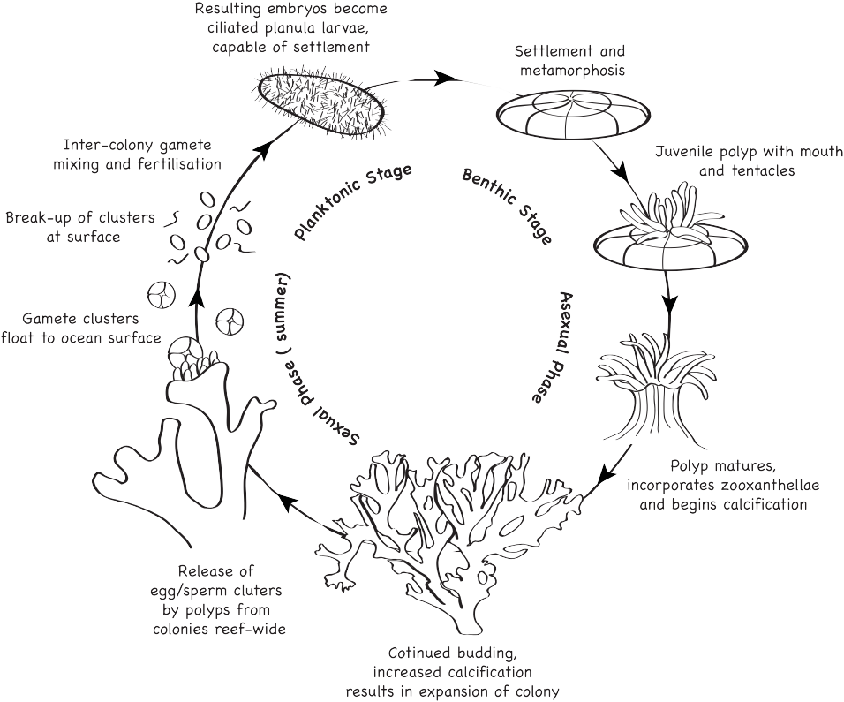

Life cycle
Corals reproduce by spawning eggs. These eggs float through the water until they find a good place to settle on the ocean floor or on top of other corals. Once the egg has settled, it starts to grow into a large colony of coral. Coral grows slowly and can take many years to develop into the large coral colonies you can see on the reef. Some of the really big corals are hundreds of years old.

Feeding
Corals eat tiny animals which drift around in the water. These tiny animals are called zooplankton. Corals also eat very small fish. These animals are caught by the coral’s tentacles that are full of specialised stinging cells.
The coral lets out its tentacles at night to catch zooplankton and small fish. Corals get most of their food from the tiny plants called zooxanthellae that live inside the coral’s cells.
Like plants, zooxanthellae use the sun to make food for themselves and the coral. This is why it is very important for coral to live in clear, clean shallow waters where they can get lots of sunlight.

Colouring
Corals can be a variety of beautiful colours. Some corals have orange, yellow, green, blue, red or purple colouring (pigment) in their tissue (their body).
They also get their colour from the plants, zooxanthellae, which live inside the coral’s cells. The zooxanthellae give many corals their brownish colour. The zooxanthellae only live inside healthy coral.

Threats to coral

Pollution
Oil and chemicals used at home can be washed down drains and out onto the Great Barrier Reef. Litter from people camping on the beach or thrown out of their boat at sea can be swept up by the waves and washed out to the Great Barrier Reef.
Pollution, including pesticides and chemicals, are washed out onto the Great Barrier Reef after rainfall where they can cause huge problems to many animals and plants on the Reef.

Anchor damage
When people anchor their boats on the Great Barrier Reef, they need to make sure they use the right anchor and do not damage the coral.
Careless anchoring can damage the coral. Chains and anchors can drag along the coral and easily break the coral. It may take years for the coral to grow back.

Climate change
Changes in weather patterns around the world mean that the temperature in the ocean is rising. Coral is very sensitive to changes in the water temperature. If the water temperature on the Great Barrier Reef increases too much, the coral will stress and the zooxanthellae will leave the coral.
This is called coral bleaching. If the water stays warm for too long, the zooxanthellae will not come back to the bleached coral. Without the zooxanthellae, the coral will starve and die.
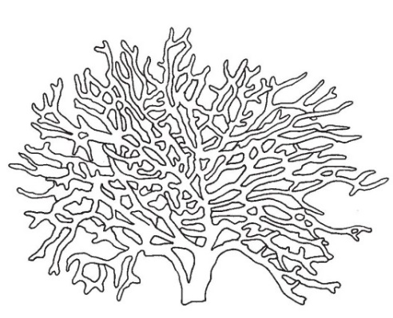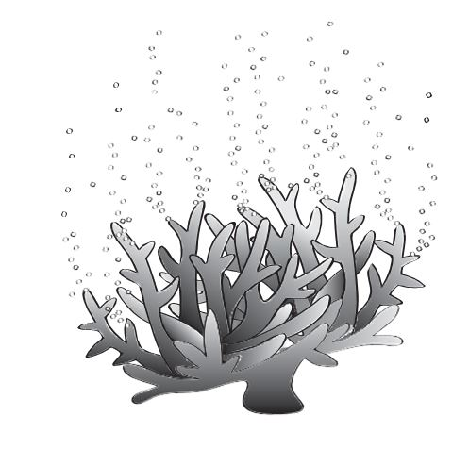

Resource 6 – Fish fact sheet
Information and images sourced from the Great Barrier Reef Marine Park Authority – http://www.gbrmpa.gov.au

Fish
The Great Barrier Reef is home to approximately 1500 different types of fish. The fish on the Great Barrier Reef come in all sorts of shapes, sizes and colours. They are a very important source of food for reef predators and for humans as well. Fish also keep reefs healthy by eating algae and other organisms that can overgrow corals.

Types of fish
The coral reef contains more species of fish than any other marine habitat. They can be divided into six broad categories:
colourful coral associates like clown anemone fish and butterfly fish
cryptic fish like blennies, gobies and seahorses that are hard to see because of their camouflage or where they live
grazing fish like blue tangs, parrotfish and wrasse
pelagic reef associates like batfish and fusiliers
reef predators like snapper, emperors, cod, grouper and sharks
nocturnal and cave dwellers such as eels, scorpion fish, squirrelfish and soldier fish.

Fish characteristics
The characteristics of a fish include a skeleton made of bone or cartilage, gill openings on each side of the head and a swim bladder. Fish vary widely in size, shape, colour and behaviour. Most fish are covered in scales.
A fish's skin or scales protect it from the salty environment in which it lives, and help it to move more efficiently through the water.
Reef fish are able to see colour. Their bright colours are important for fish to recognise each other and be protected from each other. Colour patterns can act as a warning to other animals that some fish are poisonous, for example, fire fish.
The use of colour as camouflage helps fish to hunt prey and hide from predators. Flatfish, such as rabbit fish, are able to change their colour patterns to suit the colour of the surface they are resting on. Lizardfish are so well camouflaged that smaller fish don’t see them until it’s too late and they become a meal.
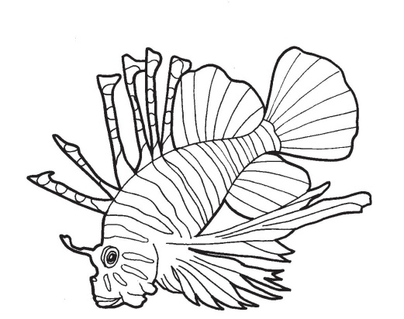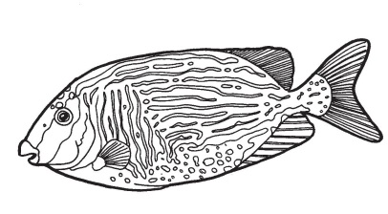
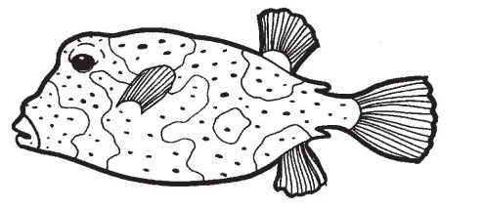

Life cycle
The majority of fish species on the Great Barrier Reef produce a mass of tiny eggs which float away and never have any further contact with their parents. Most species release large quantities of eggs into the water each year. The eggs float in the water until they are ready to hatch. When the eggs hatch, most baby fish are on their own and they know instinctively how to swim and find food.

Feeding
Fish feed on almost all available food on the reef ranging from algae to other fish.

Protection
Reef animals use their shapes, body parts and behaviour in many different ways to help them survive. Many fish have protective spines. The surgeon fish has very sharp 'blades' at the base of their tails. Members of the scorpion fish family have poisonous spines on their dorsal fins that give powerful stings. The well camouflaged stonefish has strong dorsal spines and potent venom.
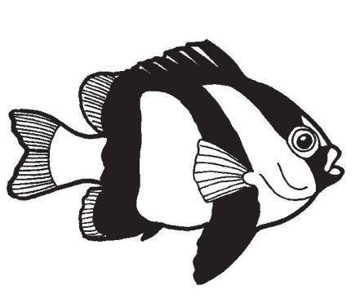
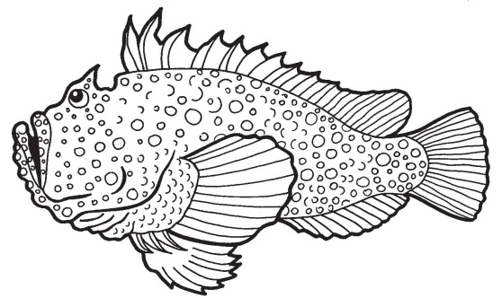
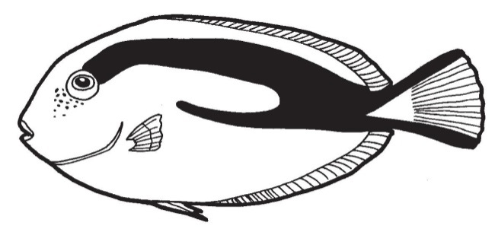

Resource 7 – Special symbiotic relationships fact sheet
Information and images sourced from the Great Barrier Reef Marine Park Authority – http://www.gbrmpa.gov.au

Goby fish and alpheid shrimp
Goby fish have very good eyesight and are very alert. The alpheid shrimp has very poor eyesight. The alpheid shrimp stay in contact with the goby fish by using their long antennae to touch the goby fish and feel what it is doing.
Should danger threaten, the goby fish quickly swims back into the burrow where it lives. This quick movement alerts the alpheid shrimp and they retreat into the burrow together. In return for its protection, the shrimp has the role of making the burrow and keeping it clean.

Remoras and large marine animals
Remoras, sometimes called suckerfish, are a type of fish that have a sucking disk on top of their head. They use this disk to suck onto sharks, rays, whales and turtles to get a free ride around the reef. In return for the free ride, the sucker fish keeps its host clean by eating parasites and bacteria off their bodies.

Clown fish and sea anemone
The sea anemone is a predator that attaches itself to rocks or coral. It uses its poisonous tentacles to attack fish as they swim by. The only fish that can survive the deadly sting of the sea anemone is the clown fish.
The clown fish will gently touch their body against the sea anemone’s poisonous tentacles until the sting no longer affects them. A layer of mucus will then form over the clown fish’s body to prevent it from getting stung again.
By living in the sea anemone’s poisonous tentacles, the clown fish is safe from predators. The clown fish helps the sea anemone by eating dead tentacles and keeping the area around the sea anemone clean.
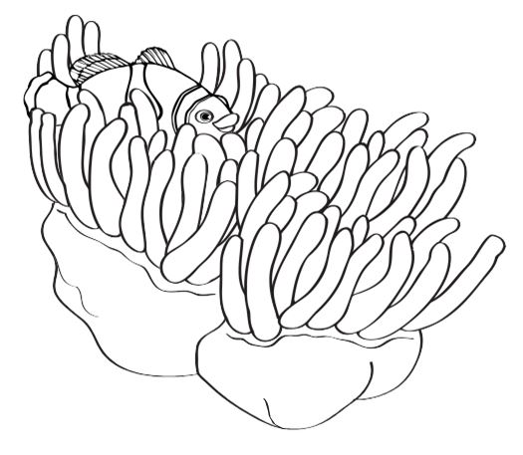

Coral and zooxanthellae
Zooxanthellae are a type of algae (very small plant) that live inside the tissue of the coral. The zooxanthellae need a place to live and they also need carbon dioxide to breath.
The coral provides the zooxanthellae with both a place to live and the carbon dioxide it needs when they breathe.
In return, the zooxanthellae use the sunlight to create sugar for the coral to eat. The zooxanthellae also give the coral its vibrant colour.

Hermit crab and shells
Hermit crabs are different from other crabs as they have a soft abdomen. To protect their abdomen, they use the discarded shells they find lying around on the sea floor.
These shells are from sea snails and other types of marine molluscs that have died and left their shell behind. The hermit crab’s soft abdomen curls around the inside of the shell, gripping very hard. This allows the hermit crab to walk and run with the shell still attached.
As the hermit crab grows bigger, it needs to find larger shells that it will fit into. Without its shell, the hermit crab does not have protection and there is a big risk that it will be eaten by hungry predators.
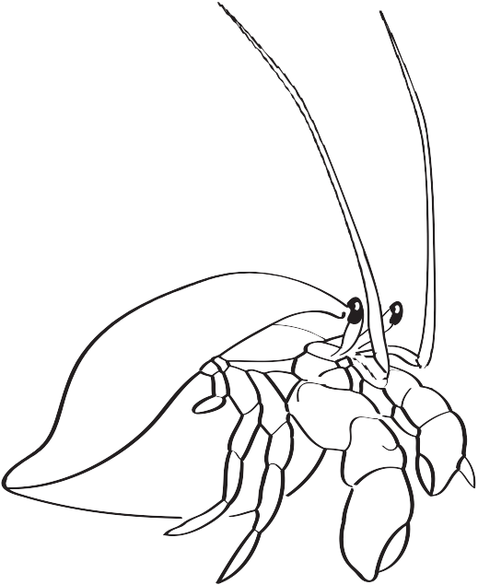

Resource 8 – Procedural text – pollution experiment

Aim
To find out how oil can affect animals on the Great Barrier Reef
Equipment per group
- One large bowl  - One measuring cup  - Water  - Cooking oil  - Old toys – variety of small plastic and small cloth toys | - Tray  - Dishwashing detergent  - Paper towels or a piece of cloth  - Sponges  - String
Procedure
- Fill half of the bowl with water.
- Measure 1/4 cup of oil and pour into the bowl of water.
- Gently shake the bowl to create ‘waves’. Did the oil and the water mix?
- Put a plastic toy into the water. Gently shake the bowl to make the toy ‘swim’. What happens to the plastic toy?
- Put a cloth toy into the water. Gently shake the bowl to make the toy ‘swim’. What happens to the cloth toy?
- Take out the toys and put them onto a tray.
- Try to use the paper towels or cloths to clean the toys. Can you get them clean again?
- Now try to clean up the oil in the bowl using the paper towels or cloths. Could you pick up much of the oil?
- Use string to make a border around the oil and try to drag the oil to one side of the bowl.
- Use the sponge to try to soak up the oil. How well does the sponge work?
- Try to clean the toys with detergent. Does the detergent help get the oil off the toys?

Pollution experiment – Observations
Write your observations below as you follow the procedure.
- Does the oil and water mix when you create ‘waves’ in the bowl?
- What happens to the plastic toy when you put it into the bowl?
- What happens to the cloth toy when you put it into the bowl?
- Do the paper towels or piece of cloth work to clean the toys?
- Do the paper towels or piece of cloth work to clean up the oil out of the bowl?
- How well does the sponge work to clean up the oil in the bowl?
- Does the detergent work to get the oil off the toys?
- How would animals on the Reef clean the oil off themselves? What would happen to them if they could not clean the oil off?

Resource 9 – Great Barrier Reef games
Turtle Danger Game – The aim of the game is to assist students in learning that marine turtles face many pressures to survive.
You will need:
- a large area to run around
- markers to identify the beach, the sea, a safety strip on the beach side and a safety strip on the seaside (see diagram below)
- a whistle.
How to play
- Discuss with students what dangers marine turtles face as they hatch from their eggs and try to get to the sea. Identify five different dangers e.g. wild pigs, people, birds, crabs, cars, lights, rubbish etc.
- Choose five students to be one of the dangers. The rest of the students are hatchlings.
- The hatchlings start on the safety strip on the beach side. When the whistle blows, they have to get to the safety strip on the other side of the ocean without getting caught by a danger. If tagged, the hatchling has to sit down out of the game.
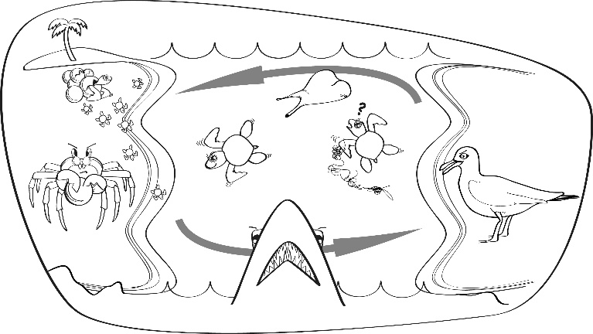
- Have a second discussion with the students to identify dangers the marine turtles face in the ocean as they are growing up. Identify five different dangers e.g. sharks, fishing nets, boat propellers, crocodiles or oil pollution.
- Now that the marine turtles are mature, they need to get back to the beach safely to lay eggs and start the cycle again. When the whistle blows, the mature marine turtles need to get back to the safety strip on the beach without getting tagged by one of the dangers. If tagged, the mature turtle has to sit down out of the game.
- Discuss how many marine turtles survived out of how many were originally hatchlings.
- The activity could be adapted by allowing more dangers to see if this affects how many hatchlings or mature marine turtles are caught. This could lead into a discussion about turtle populations on the Great Barrier Reef.

Safe habitat toss – The aim of the game is to assist students in learning about how hard it can be for some marine animals to find a safe place to live.
You will need:
- items to toss e.g. seeds, erasers, stones or model animals to represent the marine animal finding a habitat
- a game board (see examples below) made out of cardboard or paper, or the game could be drawn onto cement (this is also a good option for a big group of kids as multiple groups could play at one time).
How to play
- Discuss with students what marine animal everyone is going to be that is trying to find a safe habitat.
- Once decided, identify a number of threats that particular marine animal will face trying to find a safe habitat.
- On the game board, write the name of the threats in the boxes. Write ‘safe habitat’ in one or more boxes depending on the game board size.
- Each student receives a number of items, according to how many turns each student will get.
- Each student then takes a turn tossing their item to try and get it in the habitat.
- If the item lands in the habitat box, they get to keep it. If the item lands in a threat box, they lose their item.
- The person with the most items left at the end of the game wins.
- At the end, discuss with students if it is OK for the marine animal to be killed by native marine animals (one of the chosen threats) e.g., if students had decided on their marine animal to be a small reef fish, is it OK for a big fish or shark to eat that animal? Why or why not?
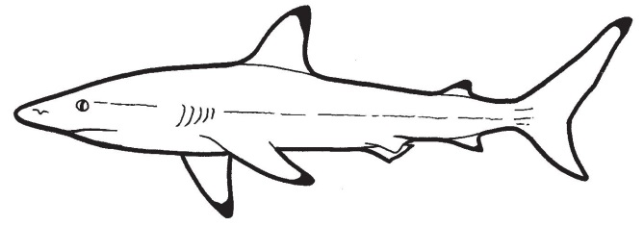
- Also discuss with students if it is OK for the marine animal to be killed by a man-made threat (one of the students’ chosen threats) e.g., if the students chose for their marine animal to be a small reef fish, is it OK for the small reef fish to be killed by eating some plastic rubbish it thought was food? Why or why not?
- This game could be made easier or harder depending on the needs of the class.

Examples of how the game board could be set up:

Option 1
Students throw from HERE  Marine animal might  be a coral trout |  | Caught in fishing net | Eaten by shark | Caught on a fishing line | Ate some plastic rubbish – thought it was food | Safe habitat

Option 2
Students throw from HERE  Marine animal might  be a dugong |  | Eaten by a shark | Caught in fishing net, drowned | Safe habitat
 |  | Struck by a boat propeller | Caught by Traditional Owners | Coastal development cause pollution, all the sea grass died
 |  | Coastal development cause pollution, all the sea grass died | Safe habitat | Eaten by a shark

Resource 10 – Cause-and-effect chart 1

CAUSE
What was the event? Who or what caused it?

IMMEDIATE EFFECT
What might happen because of the event? What could be the immediate effect?

SHORT AND LONG-TERM EFFECTS
What might happen next? What could be the short and/or long-term effects?

Resource 10 – Cause-and-effect chart 2
SHORT AND LONG TERM EFFECTS
- What might happen next?
- What could be the short and/or long-term effects?
CAUSE
- What was the event?
- Who or what caused it?
IMMEDIATE EFFECT
- What might happen because of the event?
- What could be the immediate effect?

Resource 11 – Student task sheet and Guide for making judgements

The Great Barrier Reef - Year 3 - Poster and simple report

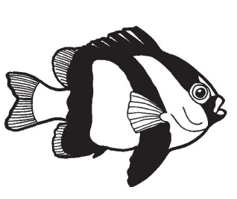
Your task:
Create a poster of a Great Barrier Reef habitat. You will also write a small report of a threat to living things found on the Great Barrier Reef.

What to include in your poster:
Drawings or images of living and non-living things found on your Great Barrier Reef habitat.
Try to include everything you can think of in the habitat including common things e.g. fish or coral and more unusual or less common things.

What to write on your poster:
Label each thing in your poster as ‘living’ or ‘non-living’.
Label and describe the observable features for each living or non-living thing.
For each living thing in your poster, write a small explanation next to it to explain why it is living. In your explanation, think about some of the characteristics that make this thing alive e.g. how it moves, what it eats, how it responds or how it grows and reproduces (life cycle).

What to write in your simple report:
Identify a threat to living things in the Great Barrier Reef.
Describe ways that this threat could affect living things in the Great Barrier Reef.
Provide suggestions for ways to address the threat.

Year 3 Science: Great Barrier Reef — Poster and simple report | Name:
Purpose: To identify all living and non-living things in a Great Barrier Reef habitat and describe their observable features. To explain why the common living things identified are living. To identify a threat to living things on the Great Barrier Reef and ways to address the threat with links to scientific knowledge.
Explains how relationships with other living things and the environment assist or hinder its survival
Science Understanding |  | Science as a Human Endeavour |  | Science Inquiry Skills
Biological sciences |  | Use and influence of science |  | Communicating
Identifies all the living and non-living things in a Great Barrier Reef habitat and describes their observable features. Explains why the common living things identified are living |  | Uses scientific knowledge to identify a threat to living things on the Great Barrier Reef and ways to address the threat |  | Communicates information and ideas by using written language and visual representations
 | Reasoned explanations for why the common living things identified are living and explanations of more uncommon living things |  | Describes and explains a threat to living things on the Great Barrier Reef and ways to address the threat with links to scientific knowledge |  | Communicates coherently | A
 | - Informed explanations for why the common living things identified are living with attempts at explanations of more uncommon living things |  | - Describes a threat to living things on the Great Barrier Reef and ways to address the threat with links to scientific knowledge |  | - Communicates using relevant scientific terminology throughout | B
 | - Identifies all the living and non-living things in a Great Barrier Reef habitat and describes their observable features. Explains why the common living things identified are living |  | - Identifies a threat to living things on the Great Barrier Reef and ways to address the threat with links to scientific knowledge |  | - Communicates information and ideas by using written language and visual representations | C
 | - Identifies all the living and non-living things and describes their observable features. Partial explanations for why the common living things identified as living are living |  | - Provides simple statements about a threat to living things on the Great Barrier Reef and ways to address the threat |  | - Communicates information and ideas using everyday language | D
 | - Recalls some living and non-living things and describes some of their observable features |  | - Recalls a threat to living things |  | - Fragmented communication of information and ideas | E
Teacher feedback:

